Docker

What we gonna do?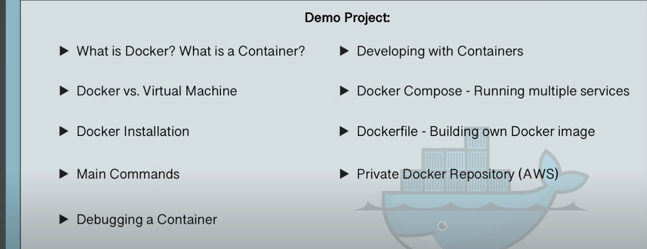

* A way to package application with all the necessary dependencies and configuration.
* Portable artifa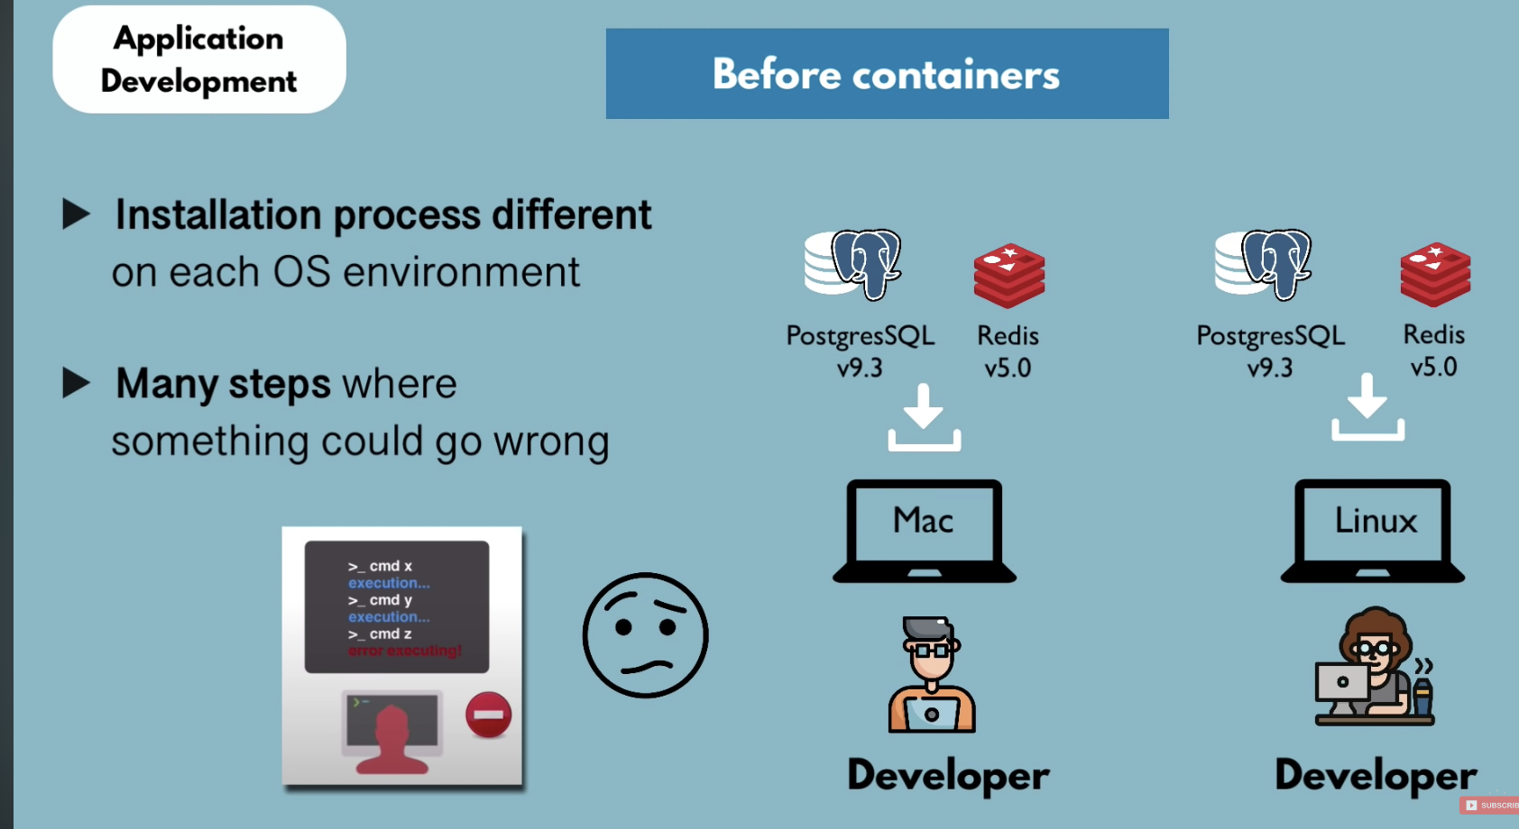ct, easily shared and moved around
* Makes development and deployment more efficient.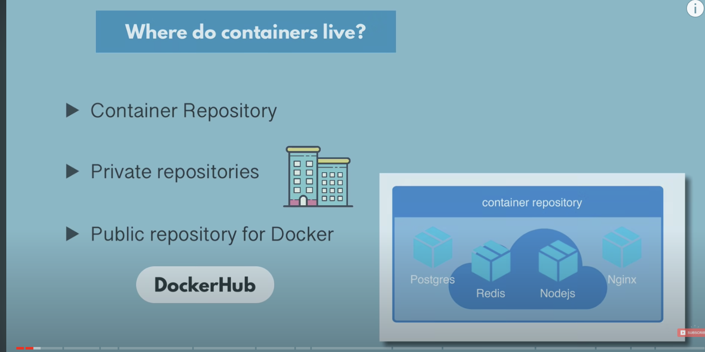

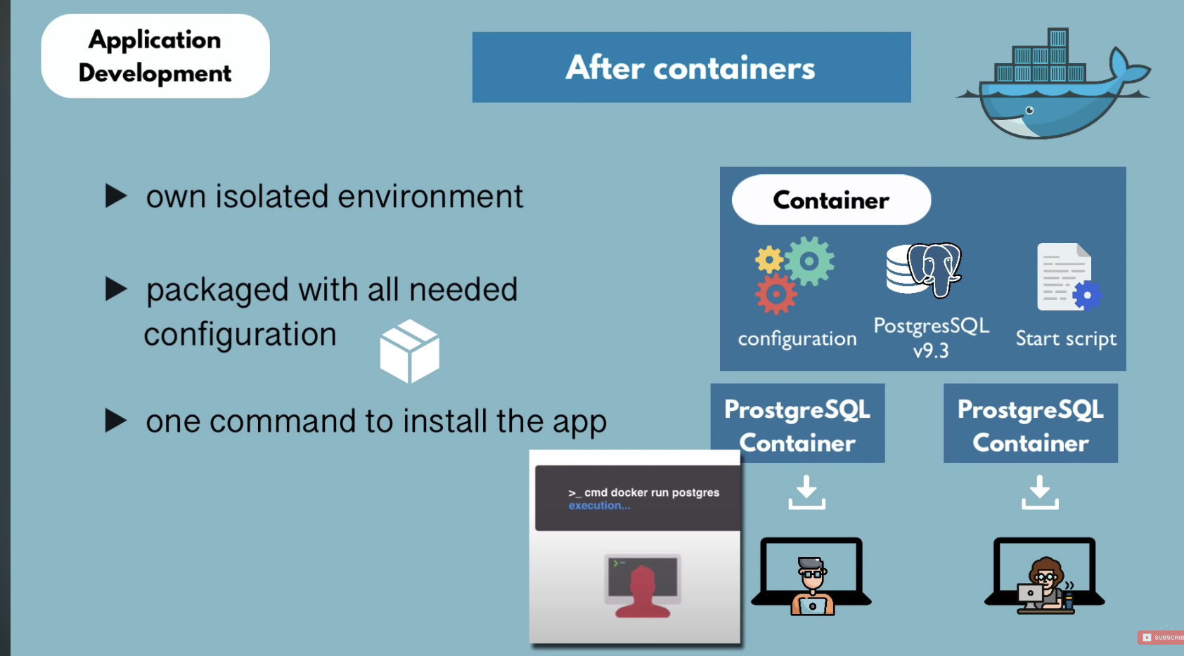

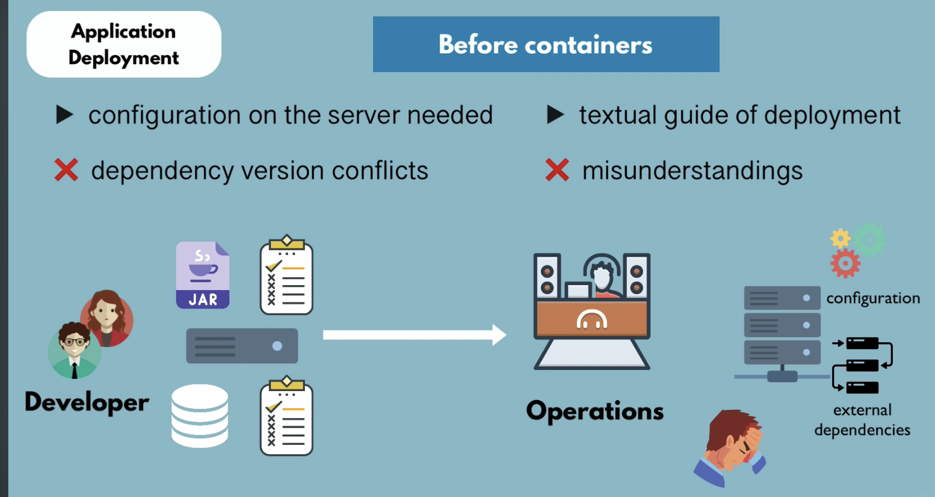

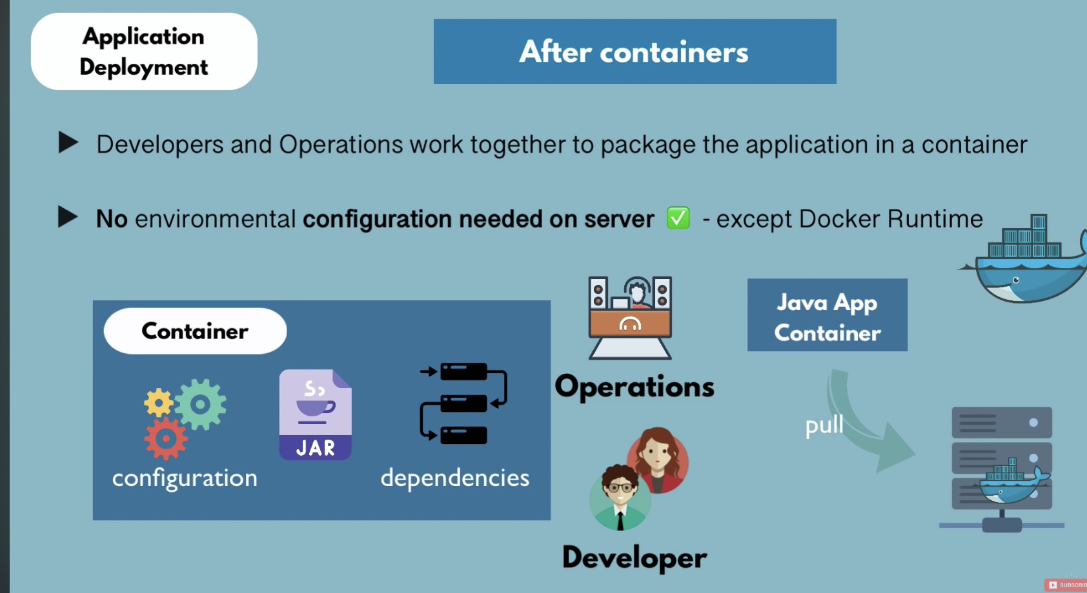

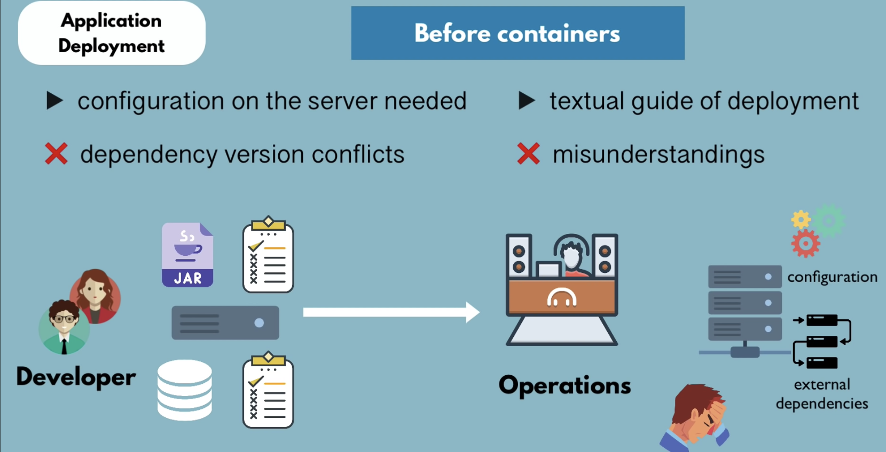

**~%ps aux**

The ps aux command is a tool to monitor processes running on your system.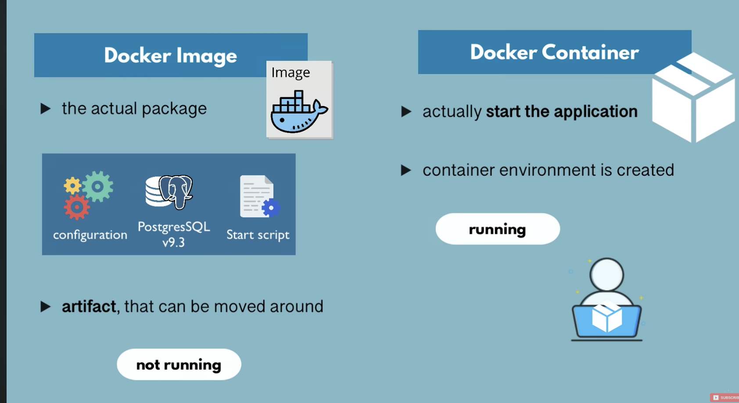

**Doker Vs Virtual Machine: -**

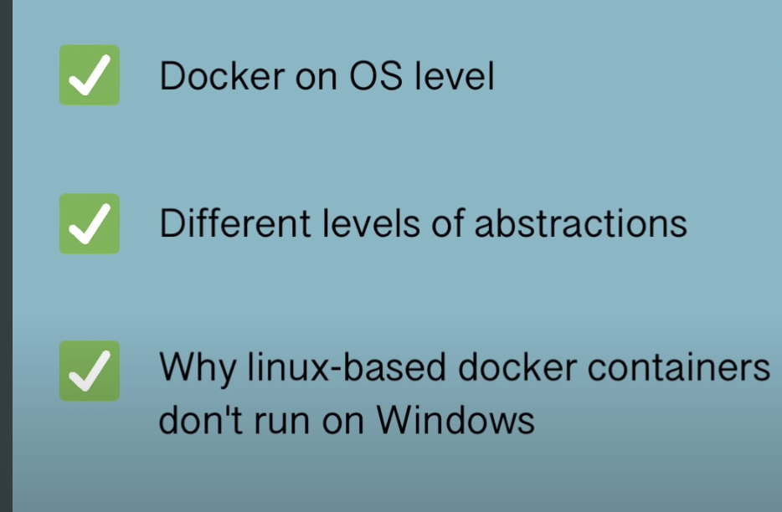

So operating system has two layers

Application layer and OS kernel(it communicates with the hardware like CPU, memory, etc. and the applications run on the kernel layer.

As you know that docker and virtual machines both are virtualisation tools.

So here comes the question, what part of the operating system they virtualise?

So, docker virtualises the application layer so when you download a docker image. So when you download a docker image it actually contains a application layer of the OS and some other application and installed on top of it and it uses the kernel of the

host because it doesn’t have it’s own kernel the virtual box or virtual machine on the other hand, has the applications layer and its own kernel. So it virtualises the complete operating system which means that when you download a virtual machine image on your host, it doesn’t use your host kernel. It puts up its own.

So, what is the difference between Docker and virtual machine actually mean? So, first of all the size of the docker images are much smaller because they just have to implement one layer.

So docker images are usually a couple of megabytes, Virtual machine images on the other hand can be a couple of gigabytes large.

The second one is the speed, so you can run and start docker containers much faster than the VMs because they every time you start them, you have to put operating system kernel and the applications on top of it.

The third difference is compatibility, so you can a virtual machine image of any operating system host, but you can’t do that with Docker. So what is the problem exactly ?

Let’s say you have windows operating system with a kernel and some application you want to run a linux based Docker image on that Windows host, The problem here is that a linux based docker image might not be compatible with the windows kernel and this is actually true for the windows version below 10 and also for the older Mac versions, which if you have seen how to install Docker on different operating system, you see that the first step is to check whether your hosts can actually run Docker natively, which basically means is the kernel compatible with the Docker images? So in that case, a workaround is that you install a technology called Docker Toolbox, which abstract away the kernel to make it possible for your hosts to run different docker images.

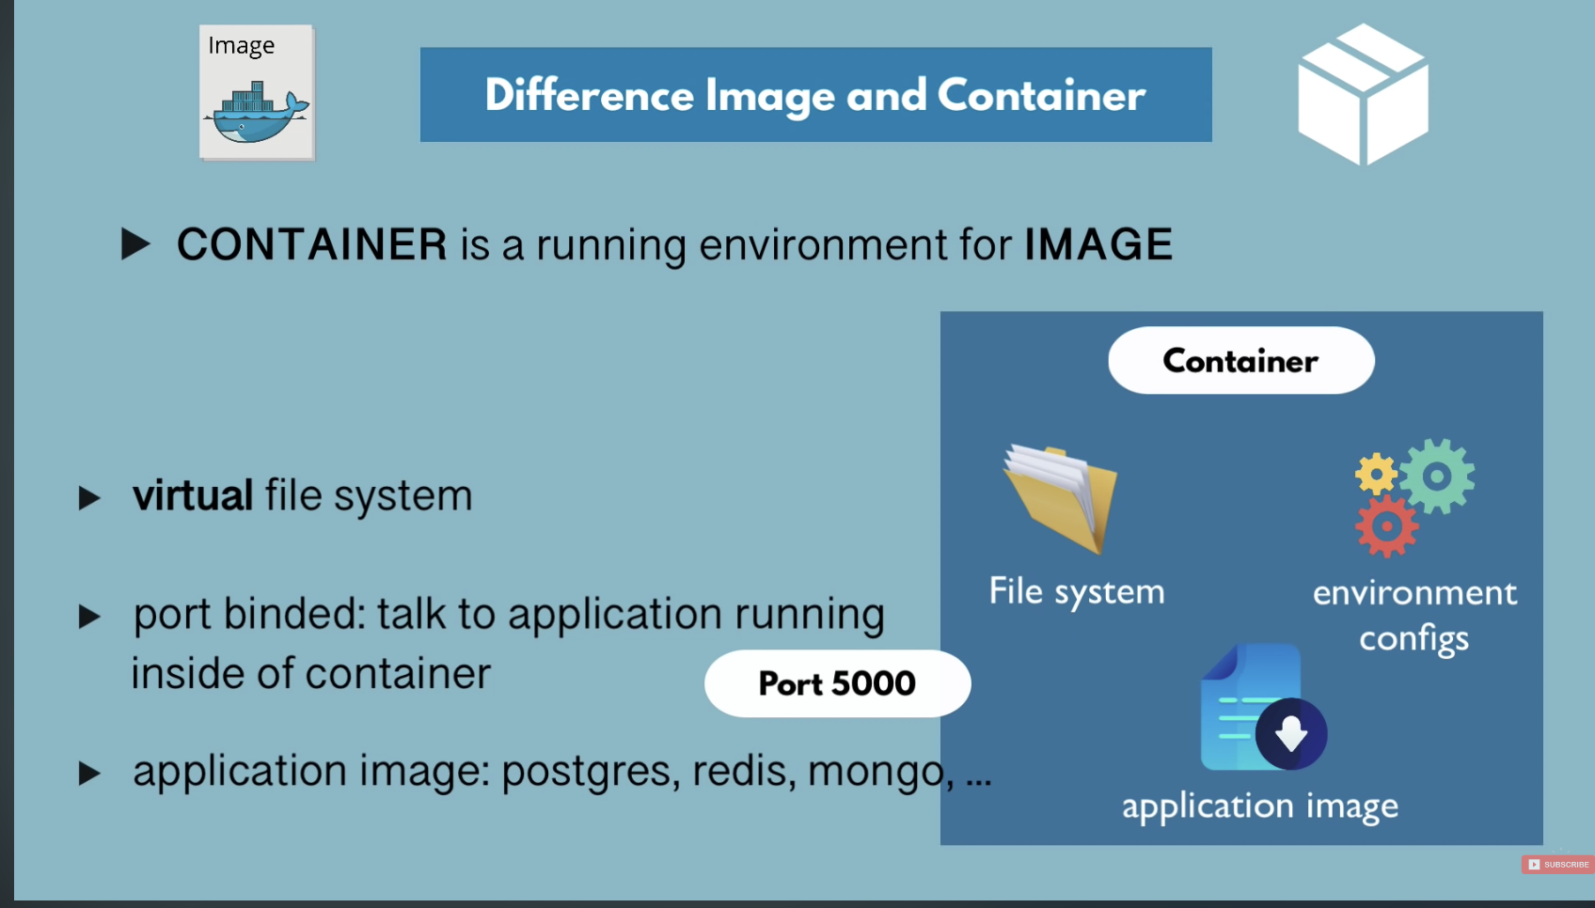

Binding between the host and the container port: -

Suppose we have to Redis container of different version

So we need to bind them to two different ports on my laptop. So the way to do it is you simply fire a command

$docker run and you specify -p i.e. the port of the host that is the first one.

So, let’s go with 6000 and the second one the port that you’re binding this to which is the container port. So we know the container port will be 6379.

So my laptop’s port 6000 will get bind with container port i.e. 6379.

**~ % docker run -p6000:6379 redis**

**~% docker run command basically combines pool and start, pulls the image if it’s not locally available and then starts it right away.**

**\*\* Command to remove all stopped container**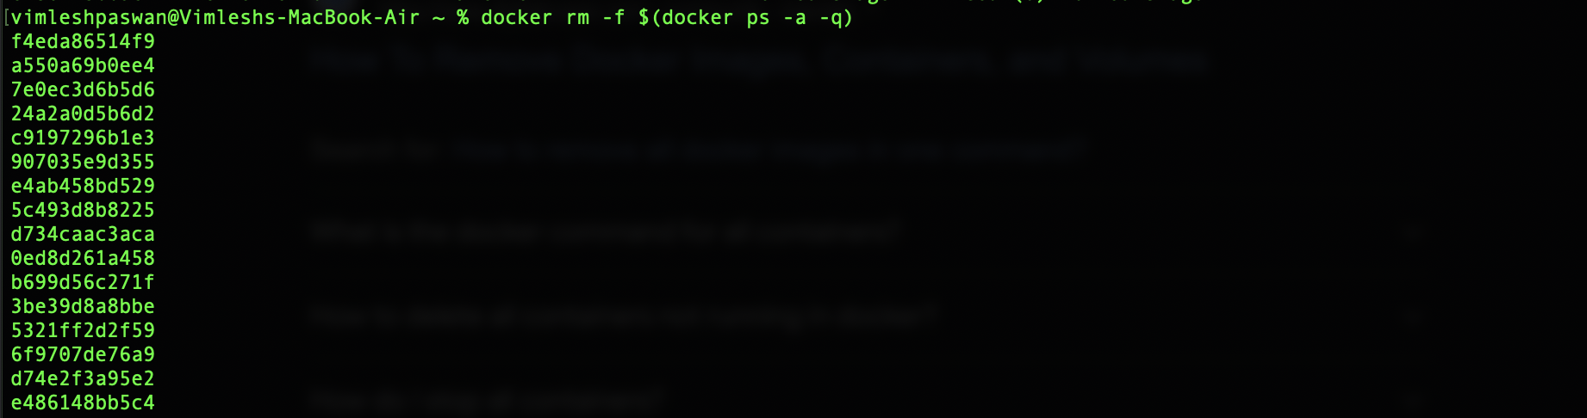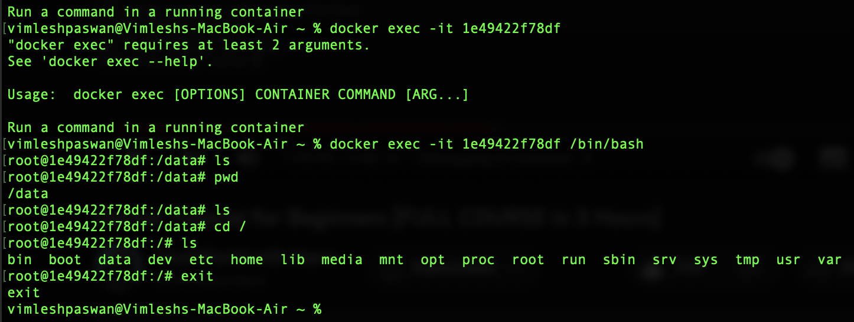

And if you want to get out the container’s terminal you fire a simple exit command and you are back your system’s terminal.

**Docker Workflow:**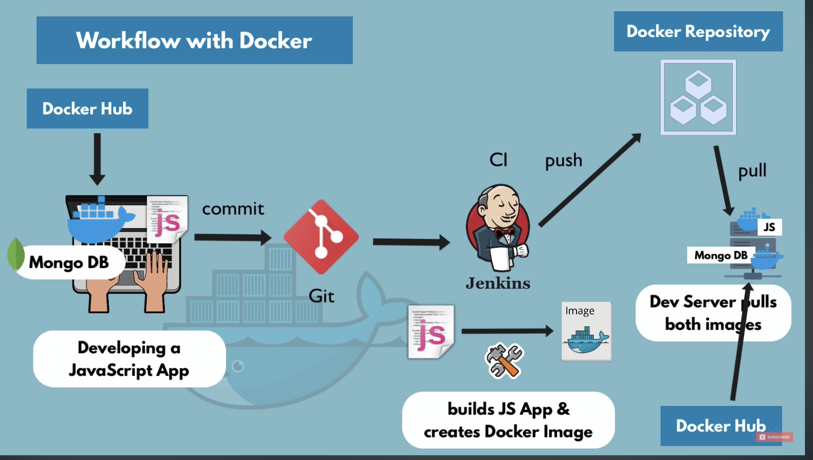

**Docker Network: -**

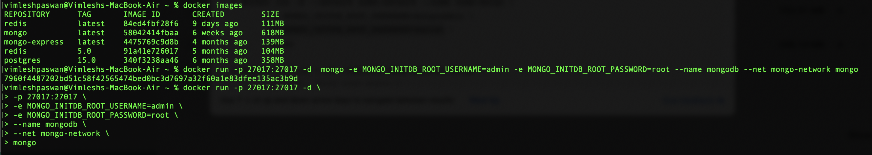

**You can see auto generated docker network with command ~%docker network ls**

**Here you can also create your own network for your images with the following command**

**~%docker network create mongo-network here, the mongo network in the name of the network.**

**I have also set the environment variable like username/password you can also create database also but I have only set the username and password for the mongo.**

vimleshpaswan@Vimleshs-MacBook-Air ~ % docker run -p 27017:27017 -d \

> -p 27017:27017 \

> -e MONGO_INITDB_ROOT_USERNAME=admin \

> -e MONGO_INITDB_ROOT_PASSWORD=root \

> --name mongodb \

> --net mongo-network \

> mongo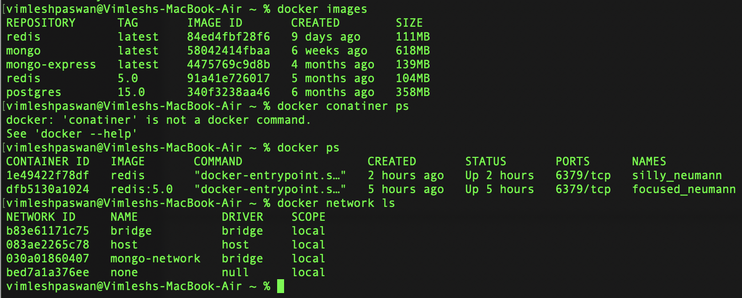

**You can see the docker network is created.**

**Docker creates its own isolated docker network where the containers are running in, so when we deploy two containers in a same docker network in my case it is mongo and mongo-express they can talk just by using their container name without localhost, port number etc. because they are in the same network. In the applications that run outside the network like nodeJs which runs from node server is gonna connect to them outside or from the host using localhost and the port number.**

**So later when we package our application into its own docker image what we’re doing to have is again docker network with mongoDB container , mongo-express container and we’re going to have a notice application which we wrote including the index HTML and JS for frontend in its own docker container and its gonna connect to the mongoDB in the browser which is running on the host but outside the docker network is going to connect to our JS application again using hostname and the port number.**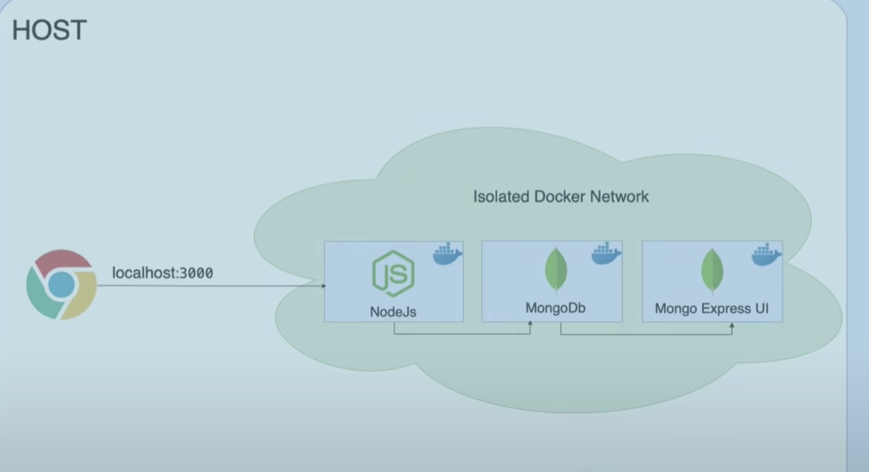

**Now we are going to create an image of our application and run it into same network:**

**Before that we need little configuration in our yaml file as you can see below:**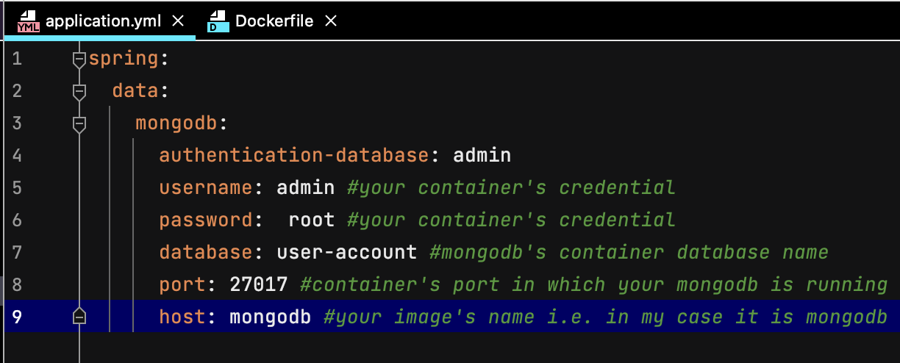

**First of all will build the jar with man build or man clean install,**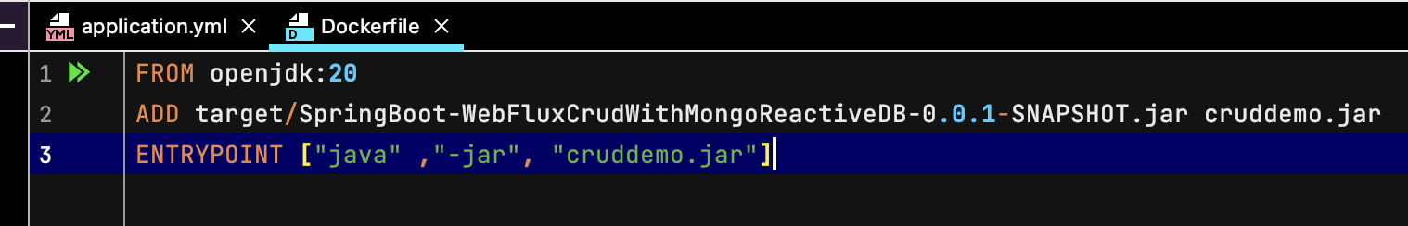

This Dockerfile defines a container image for a Java Spring Boot web application that uses the WebFlux and Reactive MongoDB frameworks.

The base image used is openjdk:20, which is an official Docker image for OpenJDK version 20.

The second line adds the JAR file of the Spring Boot application to the container image. The JAR file is assumed to be located in the target directory.

Finally, the ENTRYPOINT instruction specifies that when a container is started from this image, it should run the java -jar cruddemo.jar command, which starts the Spring Boot application inside the container.

Then we need to build the Docker image for a Spring Boot application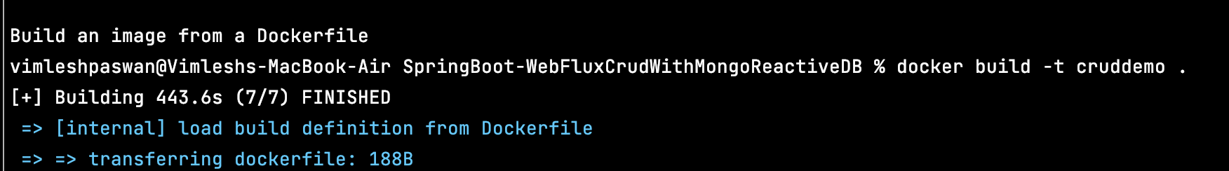

Here's a breakdown of the command:

* docker: The Docker CLI command.
* build: Tells Docker to build a new image.
* -t cruddemo: Assigns a tag to the image, which in our case is cruddemo.

* you can also specify the versioning after the cruddemo(image name) if you want Eg. cruddemo:v1.0

* . : Specifies the build context, which is the current directory.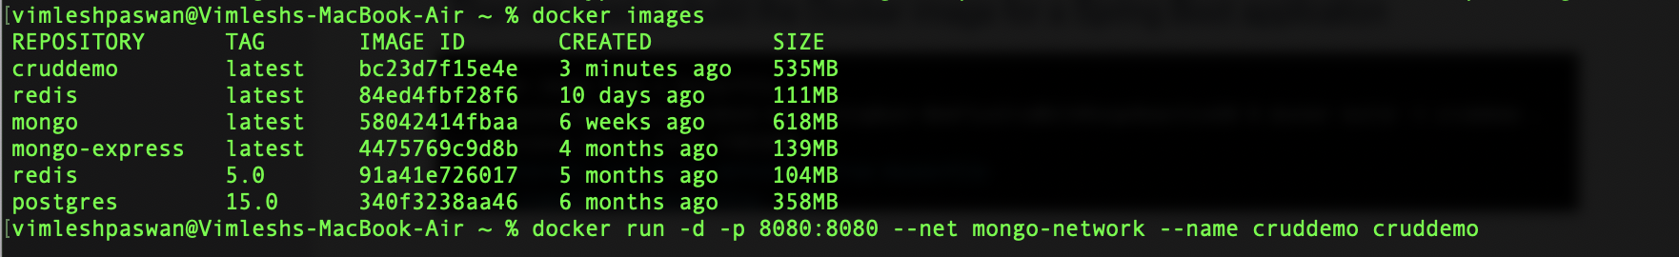

Then, you need to run this image on the same network as you can see in the above given image.

You can also see the last part of the log by using below command: -

% docker logs 2f94b83ec591 | tail

You can also stream the log with this command i.e. ~ % docker logs 2f94b83ec591 -f

**Docker compose: -**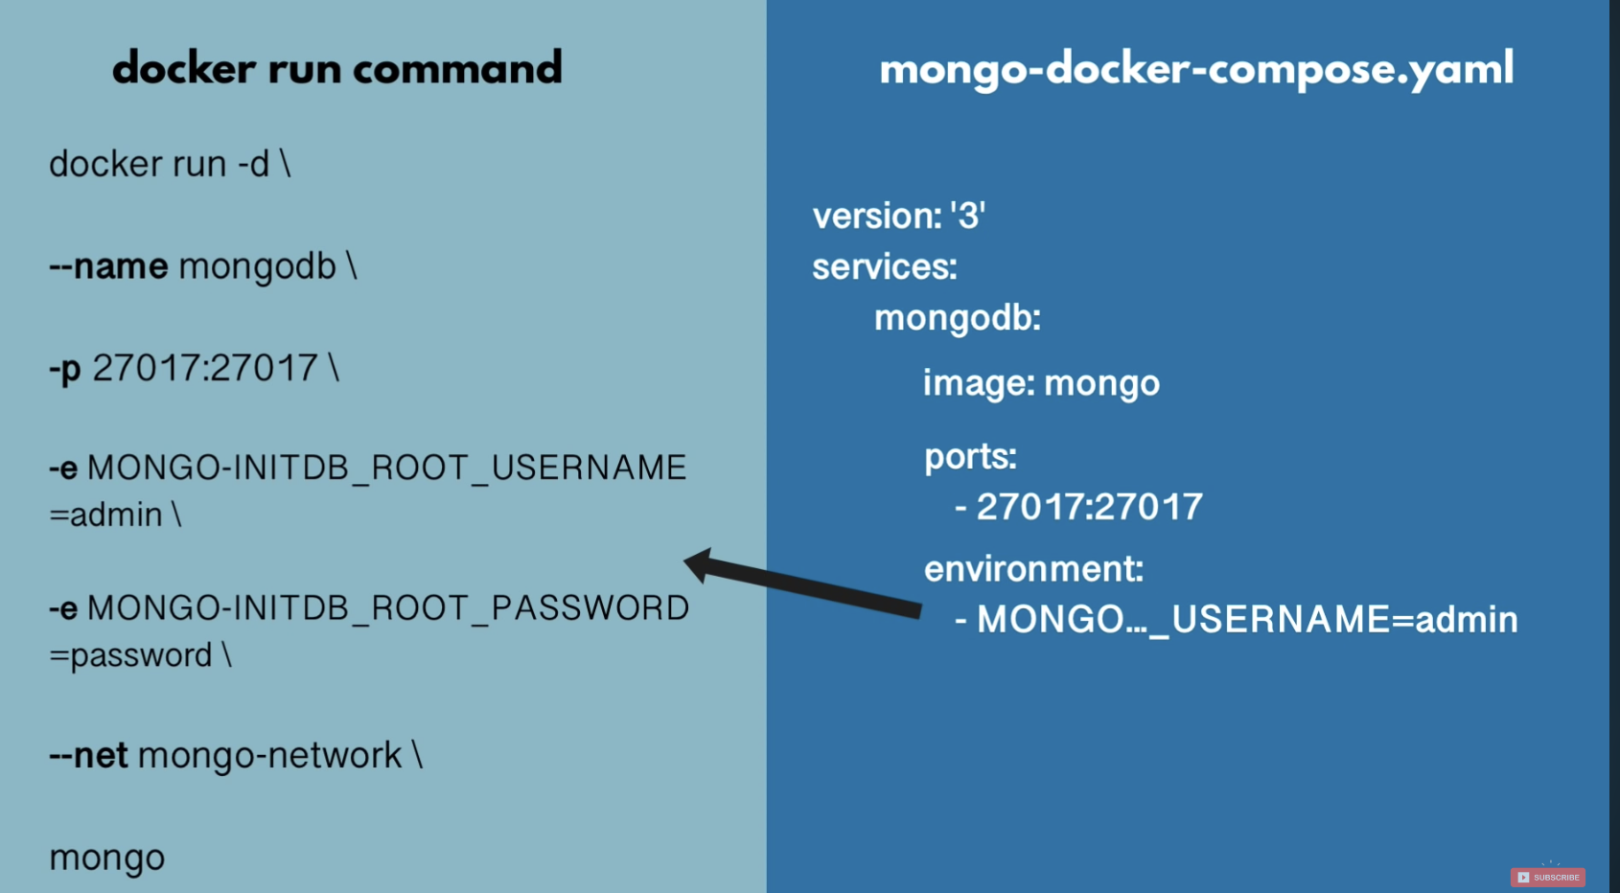

Docker Compose is a tool that allows you to define and run multi-container Docker applications. It is a command-line tool that is used to define and configure multiple containers, along with their interdependencies, as a single application. With Docker Compose, you can manage multiple Docker containers with a single command.

Docker Compose uses a YAML file to define the services and dependencies of your multi-container application. The YAML file specifies the container images to be used, the ports to be exposed, the volumes to be mounted, and other configurations needed to run the containers together as a cohesive application.

Docker Compose can be used to create a multi-container application in any environment where Docker is installed, including on-premise data centres, cloud platforms, and local development environments.

By using Docker Compose, you can simplify the process of deploying complex, multi-container applications by defining and running them as a single unit. This helps to reduce the complexity of your deployment process and makes it easier to manage and scale your application over time.